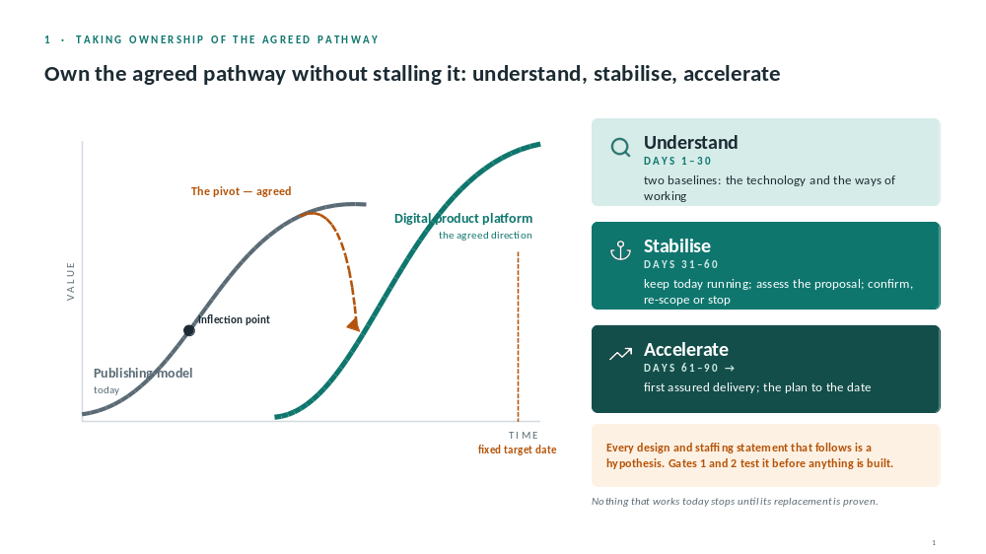

Slide 1: Own it without stalling it
- Pathway agreed, date fixed: own it, don’t stall it
- Publishing model → digital product platform; pivot agreed, shape and ways of working not
- Understand 1–30 (two baselines) · Stabilise 31–60 (keep running, assess proposal, confirm/re-scope/stop) · Accelerate 61–90→ (first assured delivery, plan to date)
- Rule 1: nothing that works stops until replacement proven. Rule 2: nothing starts without owner and gate
- Say it: everything after this is a hypothesis; Gates 1 and 2 test it
Story: inherited mid-flight
Bridge: “Here’s that on the calendar.”

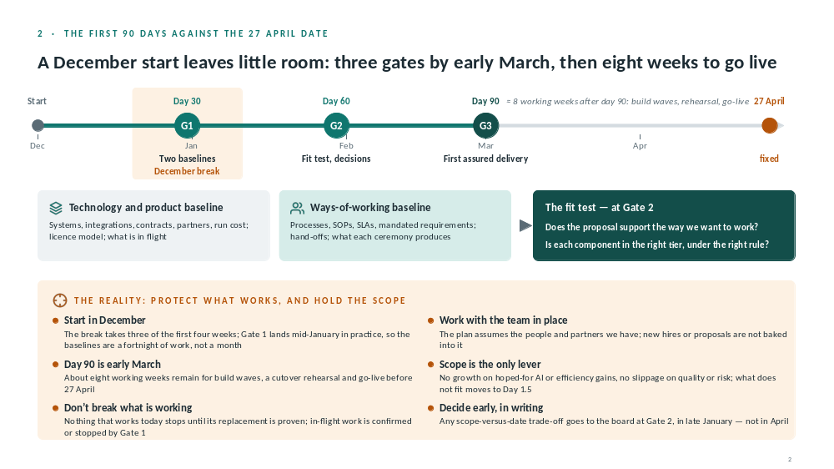

Slide 2: 90 days vs 27 April
- December start; break eats 3 of first 4 weeks; Gate 1 mid-Jan; baselines = a fortnight
- Day 90 early March; about 8 working weeks to go-live
- G1 day 30: two baselines → one-page baseline, in-flight list
- Why two: proposal = technology and products, not how we work; savings live there
- G2 day 60: fit test (supports how we work? right tier, right rule?) → the plan we’re held to. Builds on Phase 1 assurance review
- G3 day 90: first assured delivery (identity and entitlement, or content pipeline)
- Not in 90 days: commit to architecture, migrate data, extra hires, refined date or cost, AI platform before governance
- Scope is the only lever; trade-off to board at G2, late Jan, in writing
Story: fixed date
Bridge: “Next three slides: one credible shape the assessment would weigh, not the answer.”

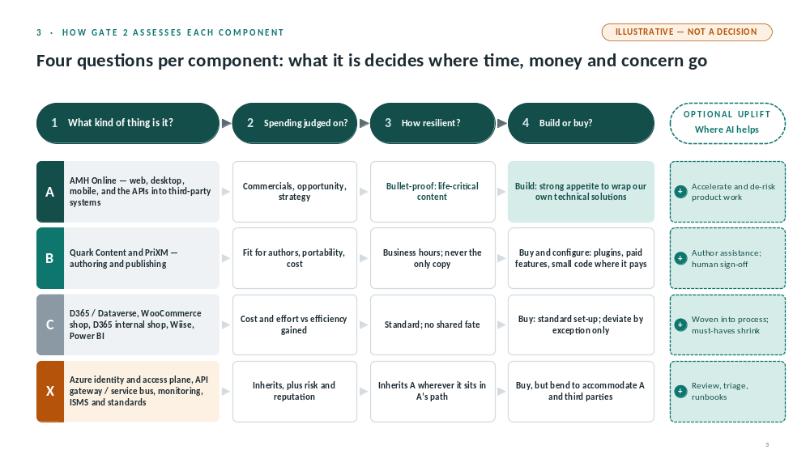

Slide 3: Four tiers, four questions
- Four questions: what kind of thing / spending judged on / how resilient / build or buy
- A product (AMH Online): moat · commercials · bullet-proof · build
- B content tooling (Quark, PriXM): content is the asset · fit, portability, cost · business hours, never only copy · buy and configure
- C commodity (D365, shop, Wiise, Power BI): cost vs efficiency · standard, no shared fate · buy, exceptions only
- X cross-cutting (identity, bus, monitoring, ISMS): inherits A’s posture · buy, bend to A
- AI: A accelerates · B assists, human sign-off · C woven in (Excel pricing step) · X triage and runbooks
- Guardrail: no AI output to content or production without a human gate
Story: commodity over build (CRM)

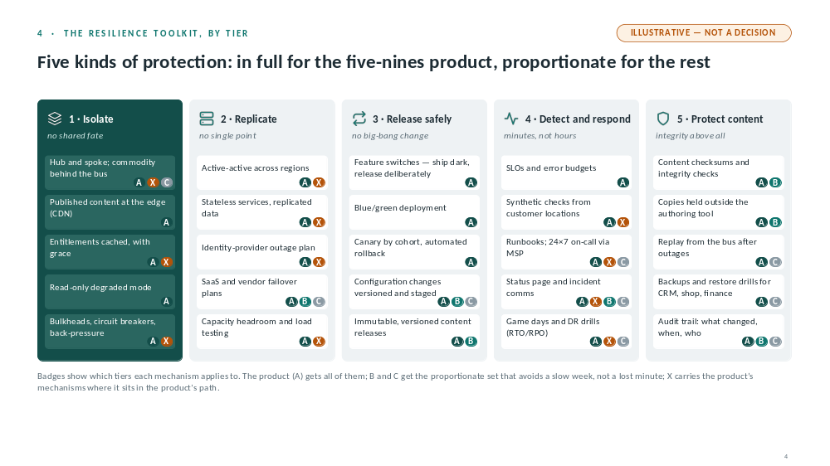

Slide 4: Resilience toolkit
- Five nines ≈ 5 minutes a year; argued from content; board’s risk appetite; no SLA in source
- No single mechanism gets you there
- 1 Isolate · 2 Replicate · 3 Release safely · 4 Detect and respond · 5 Protect content
- Hub and spoke: sync spokes (authoring, identity, third-party APIs); async behind the bus (CRM, shop, finance, reporting)
- Proportion: B and C get the set that stops a slow week, not a lost minute
- Cost sits where the risk is
Story: life-critical availability (EMIS)

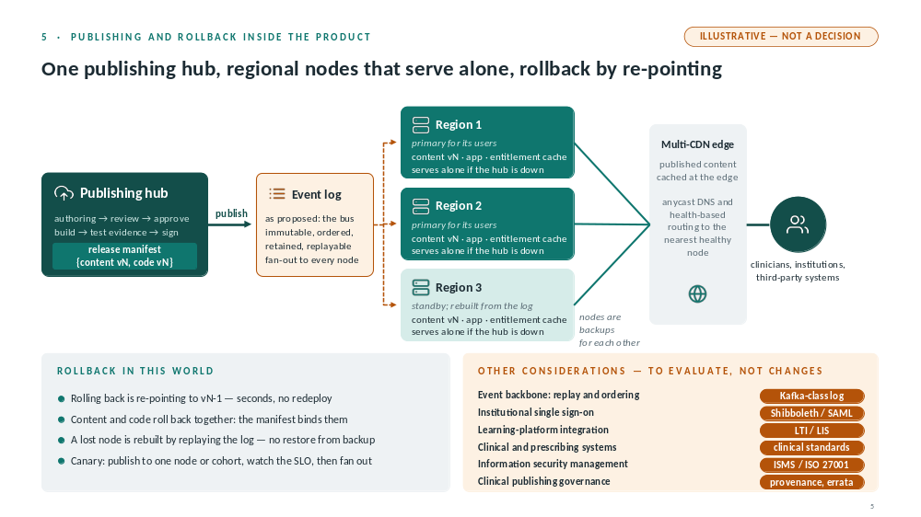

Slide 5: Publishing and rollback
- Second hub and spoke: inside the product
- Hub → manifest (content vN + code vN) → event log → nodes
- Log: immutable, ordered, retained, replayable; requirements not a product choice
- Nodes serve alone; Region 3 rebuilt from log; multi-CDN edge, health-based routing
- Rollback = re-point to vN-1, seconds, no redeploy
Consideration, not a decision: managed Kafka-class log

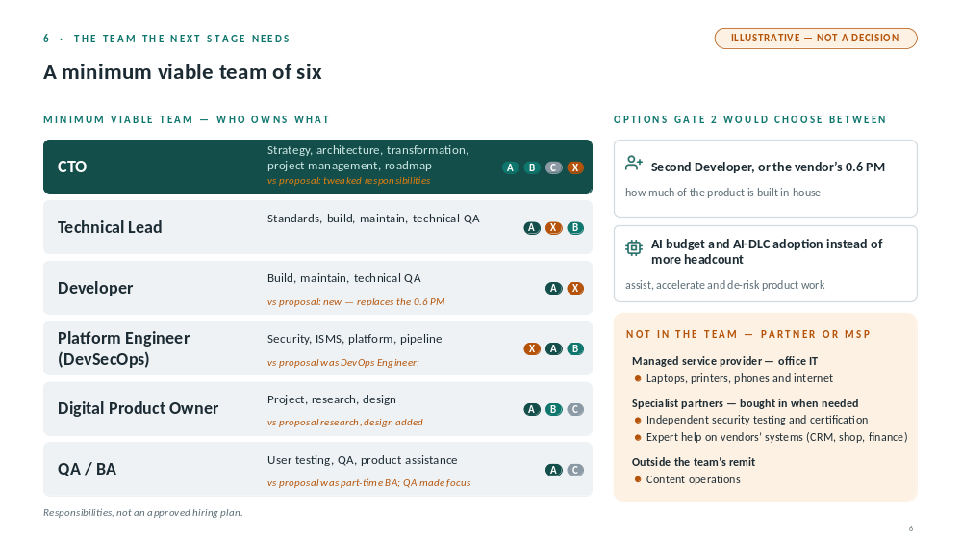

Slide 6: The team
- Worked backwards from tiers and CTO remit
- Six: CTO · Technical Lead · Developer (replaces 0.6 PM) · Platform Engineer (DevSecOps) · Digital Product Owner · QA/BA
- Why: Tier A needs two pairs of hands; key-person risk; PM sits with CTO; QA evidence for gates
- Now = the six · Over time = second developer or vendor 0.6 PM; AI budget and AI-DLC instead of headcount · Source = MSP, specialist partners, vendor experts
- Content operations outside remit
- Own judgement, not headcount; partners decide how
Story: partner or MSP; thin team (EMIS India, CallCredit Lithuania)

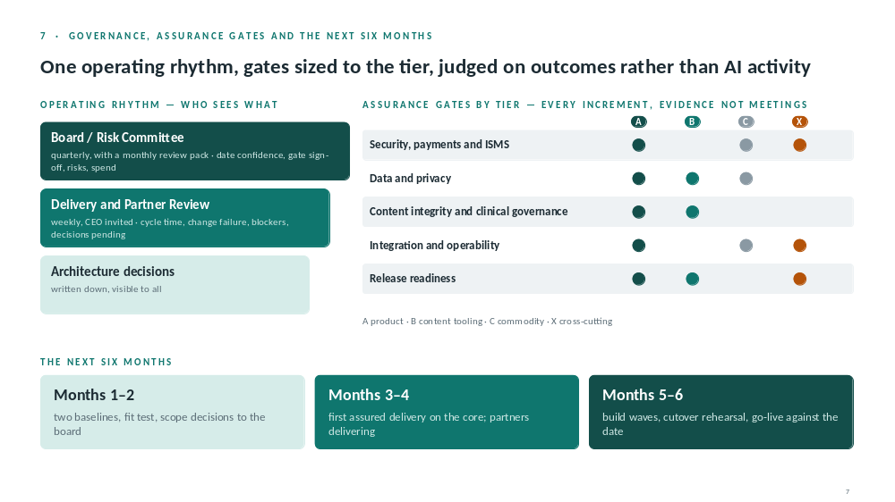

Slide 7: Governance and six months
- Board/Risk quarterly + monthly pack · weekly Delivery and Partner Review, CEO invited · architecture decisions written down · no separate steering layer
- Five gates: security/payments/ISMS · data/privacy · content integrity/clinical governance · integration/operability · release readiness
- Inward: cycle time, change failure, rework, recovery. Upward: date confidence, availability vs appetite, risks, spend, decisions pending. AI on cycle time and quality, not tokens
- Months 1–2 baselines, fit test, scope to board · 3–4 first assured delivery · 5–6 build waves, rehearsal, go-live
- Tell the Board: fixed date so scope flexes · team of six · budget to confirm · vendor dependency · content ops capacity · availability and payments across every channel

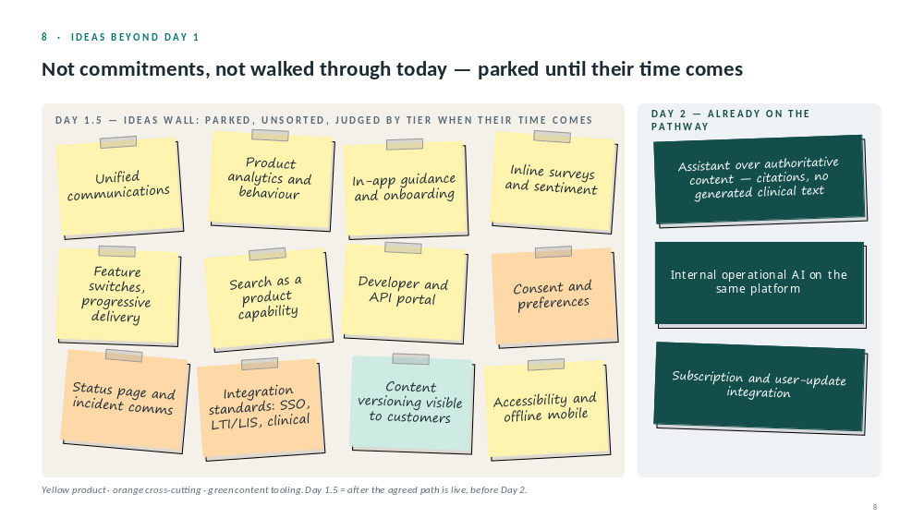

Slide 8 and close
- Don’t walk the wall: “what the proposal doesn’t show yet; judged by tier; no commitments”
- Day 1.5: analytics, consent, status page, integration standards, content versioning
- Day 2: assistant over authoritative content, citations, no generated clinical text; governance first
- Close: customers, revenue, content integrity intact · core live and bullet-proof · commodity cheap and quiet · decisions written down · Day 2 ready with guardrails set

